**KWORUS SECONDARY SCHOOL**

**P.O BOX 121 KAPCHORWA-KWEEN.**

[**TEL:0777253593/0777146352**](TEL:0777253593/0777146352) **or Email:kworusss@gmail.com**

**EOT ONE S.2 GEOGRAPHY 2024**

**Instructions: Attempt this item. TIME 1hour**

**Item 1**

Mining areas can be a bee hive of activities. Namayingo a remote village in Namayingo district in East Africa is endowed with resources like minerals, forests and streams. This enables the local people to carry out many activities as a basic source of income to support their livelihood. Investors have set up ore processing factory near the mining centre’s which are a threatening the environment. A section of the local people has come up to decompaign mining activities.

**Support material**

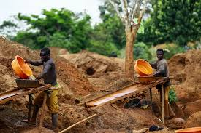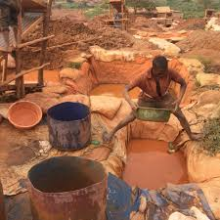

**Task**. Organize a sensitization message of 200-250 words you will present at a meeting.

**End**

**……………….………………………………………………………………………………………………………………**

**……………….………………………………………………………………………………………………………………**

**……………….………………………………………………………………………………………………………………**

**……………….………………………………………………………………………………………………………………**

**……………….………………………………………………………………………………………………………………**

**……………….………………………………………………………………………………………………………………**

**……………….………………………………………………………………………………………………………………**

**……………….………………………………………………………………………………………………………………**

**……………….………………………………………………………………………………………………………………**

**……………….………………………………………………………………………………………………………………**

**……………….………………………………………………………………………………………………………………**

**……………….………………………………………………………………………………………………………………**

**……………….………………………………………………………………………………………………………………**

**……………….………………………………………………………………………………………………………………**

**……………….………………………………………………………………………………………………………………**

**……………….………………………………………………………………………………………………………………**

**……………….………………………………………………………………………………………………………………**

**……………….………………………………………………………………………………………………………………**

**……………….………………………………………………………………………………………………………………**

**……………….………………………………………………………………………………………………………………**

**……………….………………………………………………………………………………………………………………**

**……………….………………………………………………………………………………………………………………**

**……………….………………………………………………………………………………………………………………**

**……………….………………………………………………………………………………………………………………**

**……………….………………………………………………………………………………………………………………**

**……………….………………………………………………………………………………………………………………**

**……………….………………………………………………………………………………………………………………**

**……………….………………………………………………………………………………………………………………**

**……………….………………………………………………………………………………………………………………**

**……………….………………………………………………………………………………………………………………**

**……………….………………………………………………………………………………………………………………**

**………………………………………………………………………………………………………………………………**

**……………….………………………………………………………………………………………………………………**

**……………….………………………………………………………………………………………………………………**

**………………………………………………………………………………………………………………………………**

**……………….………………………………………………………………………………………………………………**

**……………….………………………………………………………………………………………………………………**

**………………………………………………………………………………………………………………………………**

**……………….………………………………………………………………………………………………………………**

**……………………………………………………………………………………………………………..………………..**